UNIVERSITY OF PETROLEUM AND ENERGY STUDIES


Student Name: Deepanshi Shukla
Sap ID: - 590021964
Batch: B10
Course: B. Tech (CSE)
SUBJECT: python Programming lab
Experiment: 7
Submitted to:
Kamakshi Rautela

Experiment 7: File Handling and Exception Handling

1. Add few names, one name in each row, in “name.txt file”.
a. Count no of names
b. Count all names starting with vowel
c. Find longest name
CODE: -
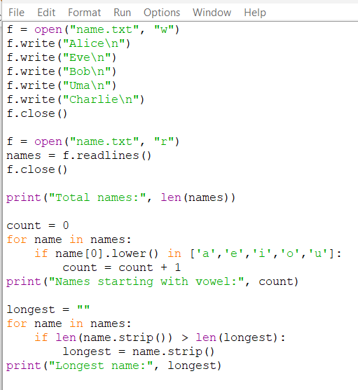
RESULT: -
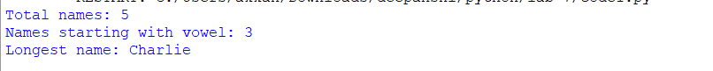

2. Store integers in a file.
a. Find the max number
b. Find average of all numbers
c. Count number of numbers greater than 100
CODE: -
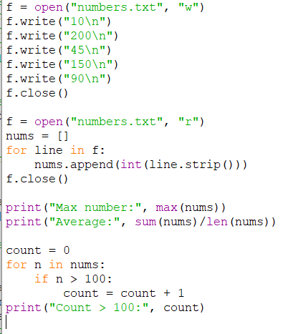
RESULT: -

3. Assume a file city.txt with details of 5 cities in given format (cityname population(in lakhs) area(in sq KM) ):
Example: Dehradun 5.78 308.20 Delhi 190 1484 …………… Open file city.txt and read to:
a. Display details of all cities
b. Display city names with population more than 10Lakhs
c. Display sum of areas of all cities
CODE: -
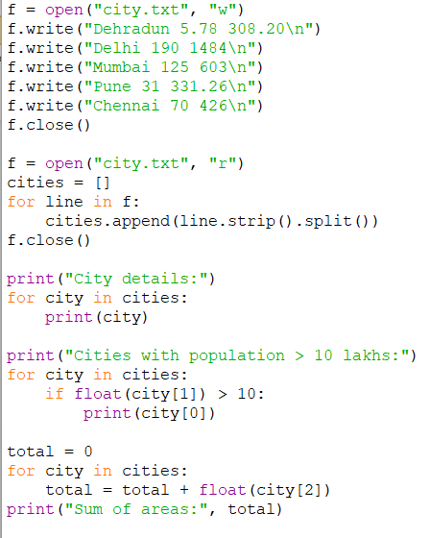

RESULT: -
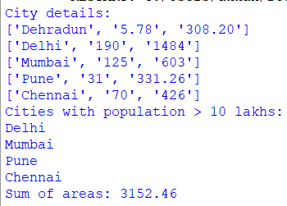
4. Input two values from user where the first line contains N, the number of test cases. The next N lines contain the space separated values of a and b. Perform integer division and print a/b. Handle exception in case of ZeroDivisionError or ValueError.
Sample input
1 0
2 $
3 1
Sample Output :
Error Code: integer division or modulo by zero
Error Code: invalid literal for int() with base 10: '$' 3

CODE: -
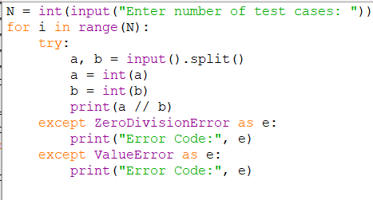
RESULT: -

5. Create multiple suitable exceptions for a file handling program.
CODE: -
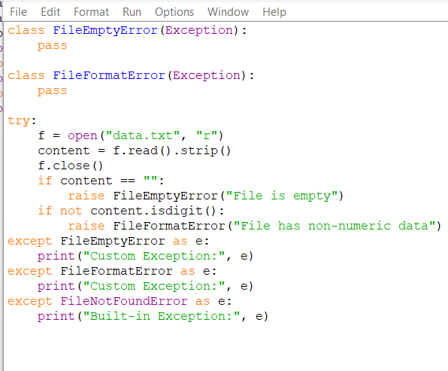
RESULT: -
6. Write a program to create a counter to show that how many times the program is executed.
CODE: -
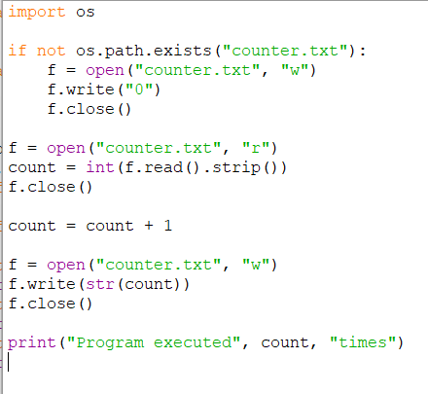
RESULT: -

